Mothers Group of companies have 4 units under it as of now, namely:
- Mothers Rice Mill
- Mothers Agro Foods Pvt Ltd
- Mothers Food Products
- MAS Foods & Spices
In the course of time, we may add new sister concern units to our group of companies.
Mothers Rice Mill is engaged in manufacturing of Rice. Its production flow chart is
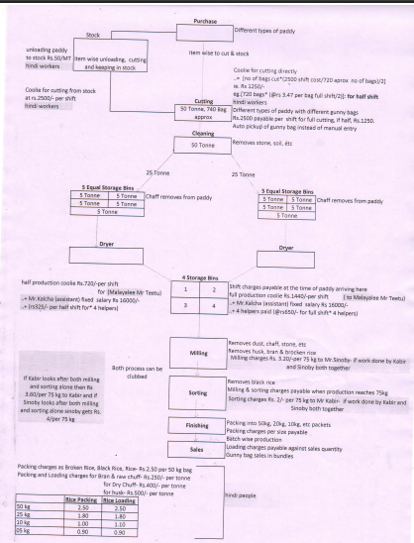

Purchase: When a load of paddy is purchased, It may be either in gunny bag or Plastic bag.
- The load reached our company, its first weight Is taken in the weigh bridge,
- After checking its quality by qc, if it is decided to unload, either it may be unloaded to stock or it may be directly taken or production
- The blend of raw materials may differ as per the quality and available of raw materials.
- The labour charges associated to each process like cutting or for production in 1 batch or 2 batches, the loading, unloading charges, etc has to go to the respective employees ledger.
- The labour charges may differ based on if the raw material is taken directly for production or if it is kept to stock and later taken for production.
- After cutting the paddy bags for production, the empty gunny or plastic bag stock has to go to their respective stock items.
- Similarly, after production when the rice is filled in 50 kg, 30 kg, 10 kg etc rice bags, the packing material stock should be reduced accordingly.
- The bi-products like dust, chaff, broken rice, black rice, husk, that come at each stage should be added to stock accordingly.
- In case the load gets rejected, they may be returned straight away, but in case of change in quality, it may be unloaded as 1st and 2nd quality etc based on their quality and rate will be decided for each quality accordingly.
- It is only at the time of making payment the rate will be decided at which the stock will be paid.
- The purchase are made through brokers at times and sometimes directly. The broker’s name must be included so that at the end of the year, we can calculate the brokerage that has to be paid to each broker.
- There are few fields of claims that has to be deducted and accordingly it has a chart for purchase, which we want it done in the software as and when we account the purchase.

Please find below the process flow chart for balance 3 firms at present:

Mothers Agro Foods Pvt Ltd.
Wheat products production flow chart:

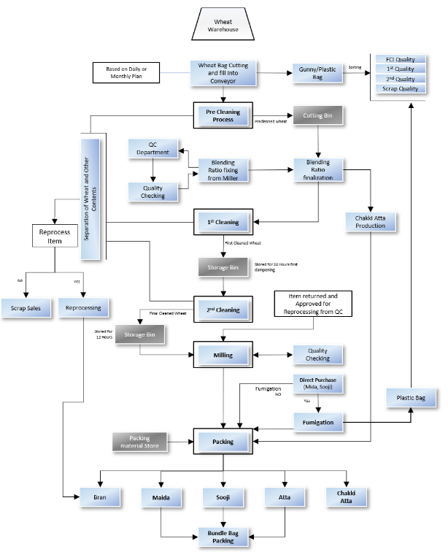

Mothers Food Products
Rice flours production flow chart:

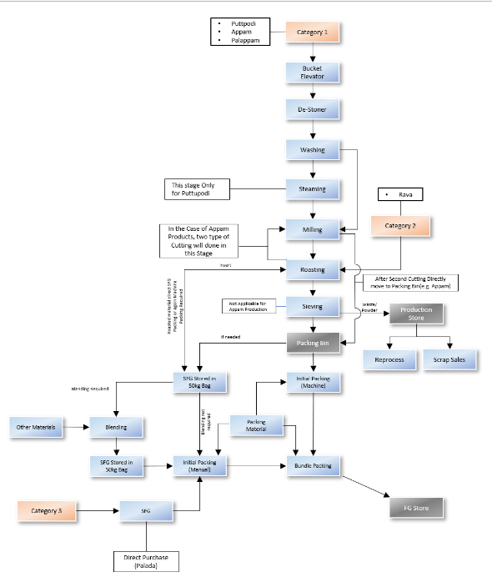

Mas Foods & Spices
Spices production flow chart
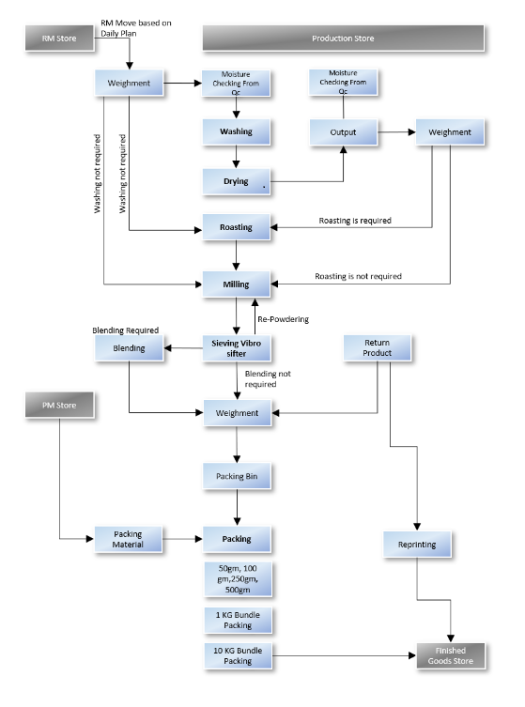

Related to all the firms in general:
Related to sales: Our sales executives and the whole sales team take the orders through a sales focus app which has to be integrated to your software. In addition, there is a POIS machine which also has to be integrated to the software which may be used for route sales & for sales done through our Outlet counter.
Also, we require more than 1 billing series for eg: 1 series for taxable items, 1 for non-taxable items, which changes alternate days, 1 series for export sales, etc.
We want the facility to take e-way bill and e-invoice where ever necessary automatically from your software soon after creating the invoice.
In the party ledger statement, suppose a party issues a postdated cheque, the party’s ledger statement should show this PDC cheque but it should not reduce the ledger balance until it gets cleared in the bank.
In addition to the sales focus app integration, our weigh bridge, our biomatrix software for attendance, and there is a software for fleet management which also has to be integrated to the software for fleet management purposes.

Please find attached some of the purchase , Open PO, daily and monthly production chart and payment & tds related reports and daily summary report that we require in addition to the usual accounts, stock and all other usual financial reports like P&L, TRIAL BALANCE, BALANCE SHEET, CASH AND FUNDS FLOW STATEMENT, CASH & BANK BOOKS, LEDGER STATEMENTS , stock statements, outstanding receivables & payables statements, movement analysis, sales & collection and outstanding reports customer wise & executive wise & area wise, distributor wise, etc for any required period of time.

Any other requirements shall be disused as and when the details of the module concerned is being worked out.

